- Create a new branch - git checkout -b ecommerce-api
- Check the status – git status
- It shows the branch name as well as the main
- Give git add to branch --- git add .
- Give git commit --- git commit -m “branch created pushing to branch”
- Push the code in branch -- git push -u origin ecommerce-api

Now in main I have all the files
- Project – order api and product api
- Files like Dependency injection notes, Microservices etc
Now in branch “ecommer-api” I have the extra file pushed as “Microservice Tutorials” along with other files that are already in the main, now I need to push this particular microservice tutorial file alone to the main from this branch instead of the entire files which already exist in the main
Traditional ways
- git checkout main – switch to main
- git pull origin main – pull lates main
- git checkout ecommerce-api -- "microservice tutorial"
It copies that single file from ecommerce-api branch into your current branch (main).
Commit and push the above in main
- git add "microservice tutorial"
git commit -m "Added microservice tutorial from ecommerce branch"
git push origin main -- Only that file is moved.

Alternative Method (Advanced – Cherry Pick)
Take one specific commit from one branch and apply it to another branch.
Here the cherry pick works for single commit only
- First find the commit id -- git log
- Switch to main – git checkout main
- Cherrypick that commit -- git cherry-pick a3f5k9d8912345(here give the commit id)
Now Git takes that exact commit and applies it to main.

What happens after giving Cherry pick command
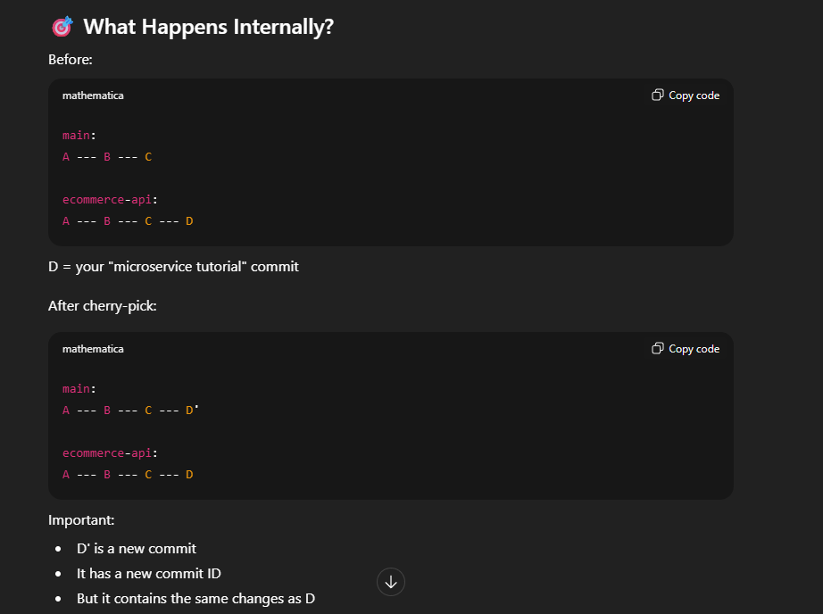

Cherry Pick vs Merge
Merge | Cherry Pick
Brings entire branch changes | Brings only one specific commit
Combines histories | Copies commit changes
Used for feature completion | Used for selective changes
Merge = copying all 5 paragraphs | Cherry-pick = copying only paragraph 3

